Meta title: In-Home Companion Care: Essential Benefits & Guidance
Meta description: Discover the transformative benefits of in-home companion care services. Ensure your loved one's safety and well-being with personalized support, aiding in independence and enriching their daily life. Perfect for families prioritizing emotional connection and practical assistance.

Benefits of In-Home Companion Care Services

You love your parent, but you simply cannot be there twenty-four hours a day. It is natural to feel a mix of guilt and exhaustion when trying to balance your own life with their increasing needs, yet you likely want to avoid moving them into a facility unless absolutely necessary. In-home companion care offers a bridge between total independence and round-the-clock medical oversight, focusing on the emotional and practical support that keeps families functioning.
Maybe you have noticed subtle changes recently, like the mail piling up on the counter or the refrigerator looking a bit too empty. These micro-signs often indicate a need for in home companion care rather than a nursing home. Think of this service as hiring a "professional friend"—a reliable presence whose job is to assist with daily routines, provide social interaction, and ensure your loved one is safe.
The primary goal of this support is to facilitate Aging in Place, which is the ability for a senior to remain in their own home independently and comfortably. While home health care involves nurses managing prescriptions or wounds, companion care focuses on the daily rhythm of life and vital aging in place safety tips. A nurse manages the medication, but a companion ensures your loved one has the water and the gentle reminder they need to take it.

More Than a Visitor: What Does a Companion Caregiver Actually Do?
While the "companion" part of the title suggests conversation and tea, the "care" aspect is where the heavy lifting often happens. You likely aren't looking for help just because your loved one is lonely; you are calling because the daily maintenance of life has become unmanageable. Companion caregivers bridge the gap between a friendly visit and practical support, tackling the small but critical tasks that allow your loved one to remain safe in their own home.
In the care industry, we classify these tasks as IADLs, or Instrumental Activities of Daily Living. This technical term simply refers to the complex thinking and organizational skills needed to live independently, such as managing a schedule, handling transportation, or meal planning. When a senior starts forgetting to turn off the stove or letting mail pile up, they are struggling with these instrumental activities. A companion acts like a personal assistant for the home, ensuring these logistical hurdles don't turn into crises.
Distinguishing these organizational tasks from ADLs (Activities of Daily Living)—which involve basic physical functions like bathing, dressing, and using the restroom—is essential. This is a key boundary in home care: while a nurse or personal care aide provides "hands-on" physical assistance for ADLs, a companion caregiver generally provides "hands-off" support. They might lay out clothes for the morning or stand outside the bathroom door to ensure safety, but they focus on the environment rather than physical contact.
Beyond the terminology, the value of a companion often appears in the immediate safety of a tidy home. "Light housekeeping" isn't just about cleanliness; it is a vital fall prevention strategy. By clearing clutter and managing chores, caregivers reduce the risk of domestic accidents. A typical visit acts as a safety net that includes:
- Meal Preparation: Cooking fresh food and checking the fridge for expired items.
- Errand Services: Picking up prescriptions or handling grocery shopping.
- Light Housekeeping: Doing laundry, changing bed linens, and keeping walkways clear.
- Medication Reminders: Providing verbal prompts to ensure pills are taken on time.
Once the physical environment is secure and the daily to-do list is managed, the caregiver can focus on an equally vital, yet often overlooked, aspect of health: human connection.

Combating the 'Quiet Crisis': How Social Interaction Protects Brain Health
Silence in a senior’s home can be deafening, but its impact on health is even louder. We often worry about physical ailments like high blood pressure, yet we overlook that chronic loneliness carries health risks comparable to smoking fifteen cigarettes a day. This "quiet crisis" of social isolation does more than lower a senior's mood; it actively accelerates physical and mental decline. When a professional companion visits, they aren't just filling time; they are providing Cognitive Stimulation, a vital process that exercises the brain through conversation and engagement. Just as muscles atrophy without movement, the mind weakens without social friction, making regular interaction a critical preventative measure.

Introducing a caregiver creates a unique mental spark that family members often cannot replicate. This "new face" effect forces the brain to wake up; your loved one has to recall old stories, process new questions, and navigate social etiquette, all of which fires up neural pathways. These cognitive stimulation activities for elderly individuals—whether it’s discussing the morning news, playing a board game, or debating the plot of a book—act as a buffer against memory loss. Research consistently shows that seniors who stay socially active maintain their verbal skills and memory longer than those who withdraw, proving that a lively chat is powerful medicine.
The benefits of social interaction for seniors also extend to the dining table. Many seniors living alone lose their appetite or skip meals simply because eating in solitude feels like a chore. A companion turns a lonely sandwich into a shared lunch, subtly encouraging better nutrition and hydration through the natural rhythm of dining together. This combination of mental engagement and emotional support transforms the home atmosphere, lifting the fog of depression that often mimics dementia and restoring a sense of purpose to the day.

Beyond Loneliness: How Companion Care Keeps the Kitchen Running and the Medicine Cabinet Safe
While a lively conversation feeds the soul, the physical demands of maintaining a household often become the first major hurdle for aging parents. The kitchen, once the heart of the home, can slowly turn into a safety hazard where forgotten stoves or expired food jeopardize health. Professional companions handle these non-medical senior support services by planning and preparing balanced meals, ensuring your loved one isn't relying on tea and toast for dinner. This consistent nutrition helps stabilize blood sugar and energy levels, preventing the physical weakness that often leads to dangerous falls.
Managing health often comes down to the daily rhythm of pills, yet confusion here creates significant risk for seniors living alone. Families must understand the legal distinction between "administering" medicine, which is a nurse's job, and "reminding," which is where a companion shines. A professional caregiver provides the structure for managing medication reminders at home by ensuring the bottle is on the table with a glass of water at the right time, though they do not physically put the pill in the senior's mouth. This gentle oversight prevents the common "did I take that already?" anxiety, keeping dosages accurate without requiring a medical professional on-site.
Giving up the car keys is frequently cited by seniors as the moment they felt they lost their freedom, but professional care can restore that lost agency. Companion care bridges the gap between isolation and activity, transforming a frightening loss of autonomy back into an active schedule. By providing safe senior transportation for medical appointments, grocery runs, or even hair salon visits, a caregiver ensures that essential tasks don't become burdens on busy family schedules. This service allows your parent to maintain their personal routine and dignity, proving that stopping driving doesn't have to mean giving up on life outside the house.
Knowing that the stove is off, the medication was taken, and the doctor’s appointment wasn't missed lifts an immense weight off a family's shoulders. When these logistical worries are outsourced to a trusted professional, the time you spend with your loved one shifts from managing crises to simply enjoying their company. This restoration of balance is vital, yet many family members still struggle to step back without guilt, which is why understanding the role of structured respite care is the next essential step in the caregiving journey.

The Gift of Time: Why Respite Care is Essential for Family Caregivers
Burning the candle at both ends eventually leads to exhaustion, a physical and emotional state professionals call caregiver burnout. It often starts quietly—perhaps you are snapping at your spouse, losing sleep, or feeling a sense of dread when the phone rings. Recognizing these signs isn't a failure of love; it is a physiological signal that you need a break to recharge. Respite care for family caregivers is the strategic solution to this common struggle, allowing you to step away for a few hours or days with the confidence that your loved one is safe, rather than waiting for a crisis to force a separation.
Stepping back actually improves the quality of support you provide to your parent by restoring your patience and energy. When you are exhausted, visits often devolve into a checklist of chores—cleaning, cooking, and medical reminders—leaving little room for emotional connection. By bringing a professional into the companion care home environment to handle these logistical tasks, you regain the capacity to simply be a son or daughter again. Your conversations can return to shared memories or current events rather than focusing entirely on whether lunch was eaten or if the laundry is done.
Establishing this balance requires finding a provider who fits your family's specific culture and desire to age in place. Many families explore reliable models like Home Instead Senior Care or similar local agencies because familiar surroundings help maintain cognitive stability and comfort. Whether you need a few hours a week to run errands or overnight support for a weekend getaway, integrating professional help ensures safety without displacing your parent. Once you decide that support is necessary, the immediate challenge becomes determining how to hire that help—navigating the critical choice between employing a direct independent worker or partnering with a managed agency.

Agency or Private Hire? Making the Best Choice for Safety and Your Budget
When looking at the bottom line, hiring a neighbor or a referral from a community board often seems like the most affordable option. True, independent caregivers typically charge a lower hourly rate, but this direct route forces you to assume the full legal role of an employer. You become responsible for comprehensive background checks, payroll taxes, and liability if an injury occurs in the home. Without the oversight of an organization, you also face the "Monday Morning" risk: if your private caregiver calls in sick or quits unexpectedly, there is no safety net, potentially leaving your loved one alone and unsafe.
Partnering with a professional agency shifts these heavy burdens off your shoulders and onto a dedicated management team. Agencies provide staff who are "bonded and insured," a crucial safeguard that protects you financially against theft or property damage while the caregiver is on-site. Furthermore, agencies solve the reliability problem by ensuring backup support is available; if your regular aide has the flu, the agency coordinates a replacement so care is never interrupted.
Snapshot: Comparing Your Hiring Options
| Feature | Private Hire (Independent) | Home Care Agency | | :--- | :--- | :--- | | Insurance | You are liable for accidents/theft | Bonded and insured by agency | | Training | Variable; hard to verify | Standardized and ongoing | | Back-up Care | None; you must fill the gap | Guaranteed replacement staff | | True Cost | Lower hourly rate + employer taxes | Higher all-inclusive rate |
Choosing between private hire vs home care agency models ultimately comes down to balancing your budget against your tolerance for risk and administrative work. While companion home care through an agency carries a higher premium, many families find that the rigorous steps to hire a reliable caregiver taken by professionals provide essential peace of mind. Of course, understanding these costs leads to the most common financial question: who actually foots the bill?

Does Medicare Pay for This? Navigating Costs and Non-Medical Home Help
One of the most common shocks families face is realizing that traditional health insurance rarely foots the bill for daily companionship. When you ask, "Does Medicare cover non-medical home help?" the answer is typically no, because services like cooking, laundry, or driving are classified as "custodial care" rather than medical treatment. Understanding this distinction early prevents sudden financial panic and allows you to pivot toward resources that actually offer support.
Fortunately, out-of-pocket payment isn't the only path for those weighing the costs of assisted living versus staying at home. Long-Term Care Insurance is specifically designed to bridge this gap, covering daily assistance that standard health plans exclude. Additionally, veterans may qualify for the "Aid and Attendance" benefit, a significantly underused program that can help pay for services from agencies like Home Instead Senior Care or local providers.
Financial planning also involves looking for hidden savings, such as tax deductions for qualified medical expenses. If a doctor certifies that home care is necessary for safety, a portion of the cost might be deductible, softening the overall impact on the family budget. With a clear picture of your funding sources established, you are ready to tackle the logistics of moving from research to actually bringing a helper through the front door.

From First Call to First Visit: Your 4-Step Plan to Hiring a Reliable Caregiver
Realizing your loved one needs help is a brave step, not a failure. You now understand that companion care home services aren't about replacing you; they are about restoring your relationship from "care manager" back to "family member." To reduce resistance, try the "Soft Entry" strategy: introduce the caregiver as a friend there to help you with the housework, rather than someone there to "babysit" them.
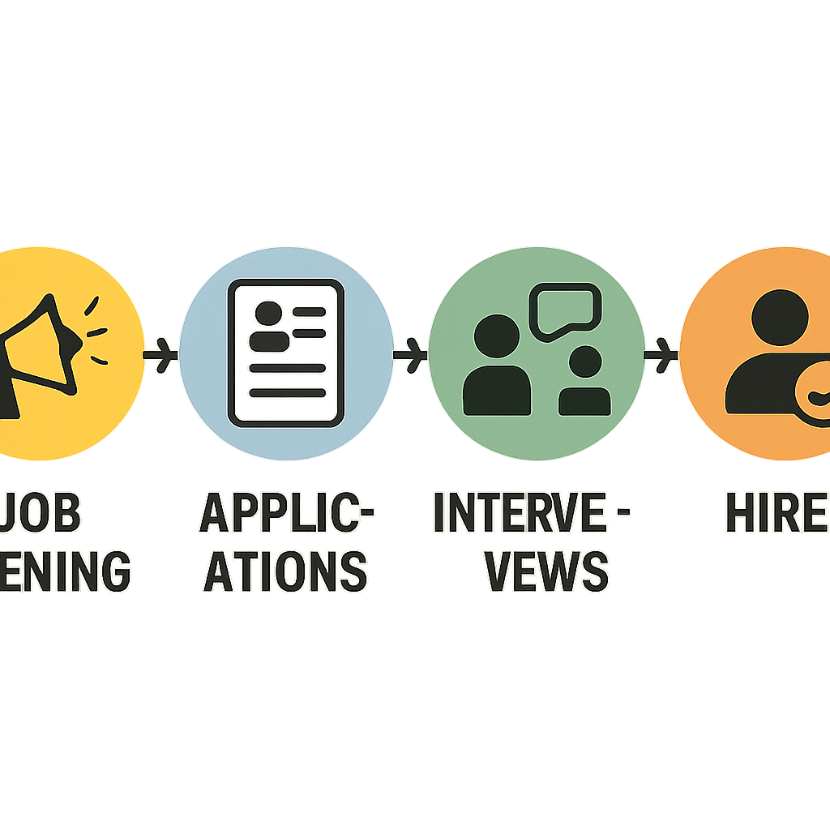
Your Roadmap to Relief:
- Book an In-home Assessment: Let experts identify safety gaps you might miss.
- Interview Strategically: Ask, "What do you do if they refuse a meal?" to test problem-solving.
- Begin a Trial Run: Start with short shifts to build rapport without pressure.
- Refine the Plan: Adjust hours based on the senior's comfort and energy.
Even complex situations like in-home dementia care become manageable when broken down into these small wins. Ask yourself: If I had just three hours of respite next week, how would my patience improve? Follow these steps to hire a reliable caregiver to turn that possibility into reality. You are ready to create a safer, happier home environment starting today.

